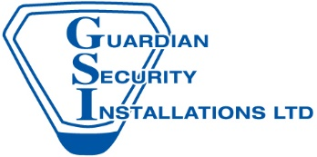

Guardian Security Installations Limited
73 South Street, Keighley, BD21 1AD
Tel: (01535) 691256

We are very pleased to announce that we have recently been accredited to an NSI Gold accredited security company.
All security companies are not the same. Guardian Security Installations Ltd is accredited Gold (the highest possible level) by the NSI, the official body of the security industry.
NSI’s mission is to raise standards in the security and fire industries in the interests of the customer. NSI -approved companies must prove their competence on an ongoing basis.
That’s certainly true of Guardian Security Installations Ltd. We focus on offering true quality equipment.

What does NSI Gold mean?
All NSI approved companies:
- Meet all relevant British and European Standards for technical performance
- Security screen all relevant staff
- Provide a high level of staff training and supervision to industry best practice standards
- Are comprehensively insured to protect customers and staff
- Are inspected regularly by professional auditors, including random site visits
NSI Gold companies also:
- Meet the industry specific ISO 9001:2008 Quality Management System Standard
- Demonstrate a long-term track record of performance, and evidence of reliability and stability
Working with Guardian Security Installations Ltd gives you the unbeatable reassurance of NSI Gold standards. To get a quote or just to discuss your requirements, contact us today. We’re always happy to offer help and advice without obligation.
