Guardian Security Installations Ltd
73 South Street, Keighley, BD21 1AD
Tel: 01535 691256

- We are pleased to introduce our new member of staff, Craig Newell. Craig has joined our team as one of our Installation Engineers. Craig has previous experience working in the security industry as an alarm engineer. His main duties will be installation of Burglar alarms, CCTV, Fire systems and
door access systems. We hope that Craig will enjoy working for us and become a valid member of our team.

- We have been very busy fitting our new type of bell boxes which are back lit and light up at night. If you would be interested in one of these type of bell boxes please contact our office on Tel: 01535 691256.
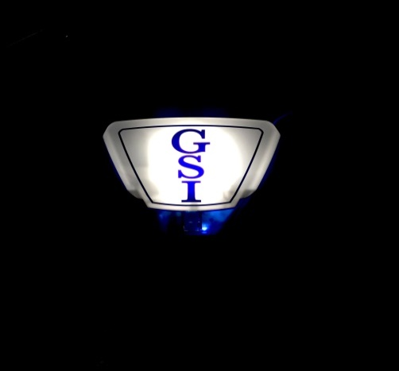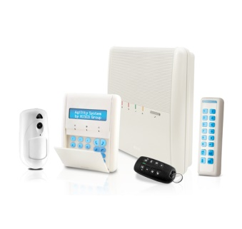
- We are now fitting the Agility™ 3. This is a state-of-the-art 2-way wireless alarm system designed for the residential and small business markets that provides more than a standard home security system.
Agility™ 3 supports visual verification with a self- monitoring Smartphone app (also available via web browser) which enables homeowners to control their alarm systems remotely, as well as view real-time images taken inside their premises with the eyeWave™ wireless PIR camera detector which communicates with the RISCO Cloud server.
In the event of an alarm, the PIR camera is automatically activated and captures a sequence of images which it sends to users via RISCO's Smartphone/ web Application. This capability enables users to view the images and confirm if there is a crime in progress. Monitoring stations can also benefit from the visual verification feature as the capability to ascertain whether there is a false alarm will save them valuable time and resources.

