Guardian Security Installations Ltd
73 South Street
Keighley BD21 1AD
Tel: 01535 691256

One of the systems we are currently fitting is the:

Pyronix Enforcer V10

You can set and unset the system, get system status and receive custom push notifications from any event, on your mobile phone or tablet. Giving you complete control from anywhere in the world.

In this digital age we continue to demand products and services which are more aligned with our lifestyle; products which allow us to stay connected all the time. The Enforcer V10 realises that opportunity by providing IP connectivity through the inbuilt WIFI modem and ProControl+ app available on iOS and Android devices.
The Enforcer V10 is connected through a cloud server, so there is no need to set up static IP addresses or configure the network connection on site, instead you simply set up an account on PyronixCloud.com.
Add IP cameras to the system for live stream monitoring of the property.
For further details and a FREE QUOTE call us on Tel: 01535 691256
- 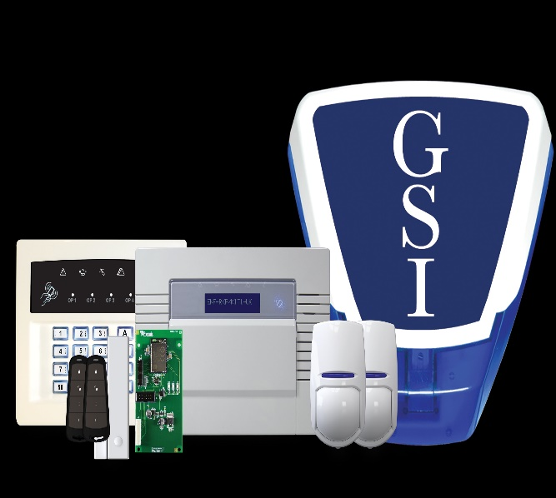
For

